Tour name: 7-Day Grand Expedition Across Turkmenistan: From Ancient Civilizations to Natural Wonders
Tour Description:
This 7-day expedition offers a deep and diverse journey through Turkmenistan’s most remarkable cultural, historical, and natural highlights. From the white-marble grandeur of Ashgabat to the flaming Darvaza Gas Crater, from the ancient Silk Road legacy of Merv to the dramatic landscapes of Yangykala Canyons and the traditions of mountain villages, this itinerary combines archaeology, spirituality, desert adventure, and scenic beauty into one unforgettable experience.
Starts at: Ashgabat
Ends at: Ashgabat
Please note: The starting and ending points of the itinerary may be adjusted depending on the client’s request, logistics, and tour format.
Group size: 3+
Days: 7
Price: From 1350 USD per person
Pricing note: The tour price depends on the number of participants. The more people join the tour, the lower the price per person will be.
Tour itinerary:
Day 1 | Arrival in Ashgabat: The White-Marble Capital  Arrival at Ashgabat International Airport, where you will be met by your guide and transferred to your hotel.  Your journey begins in Ashgabat, the capital of Turkmenistan, renowned for its monumental architecture, elegant urban planning, and striking white-marble buildings. Start your city discovery with visits to the Independence Monument, one of the country’s most important national landmarks, and the Neutrality Monument, one of the defining symbols of modern Ashgabat.  Continue to the Alem Cultural and Entertainment Center to see the famous indoor Ferris wheel, an impressive example of the city’s modern architectural ambition. You will also visit the Memorial Complex, dedicated to important moments of national history and remembrance.  In the evening, enjoy a panoramic night tour of Ashgabat, when the city reveals its most impressive atmosphere through illuminated monuments, marble facades, and grand ceremonial avenues.  Overnight at a hotel in Ashgabat.  Distance of the day: approx. 30–50 km
Day 2 | Ashgabat – Old Nisa – Akhal-Teke Horses – Ruhy Mosque – Darvaza  After breakfast, continue exploring the cultural and historical highlights of Ashgabat and its surroundings.  Begin with a visit to the National Museum of Turkmenistan, which offers an excellent introduction to the country’s archaeology, history, and cultural traditions. Then continue to Old Nisa, a UNESCO World Heritage Site and one of the most significant archaeological monuments in Central Asia. Once a royal residence of the Parthian Empire, Old Nisa remains one of Turkmenistan’s most valuable ancient treasures.  The tour continues with a visit to the Akhal-Teke horse stables, where you will encounter one of the country’s greatest national symbols. Known for their elegance, endurance, intelligence, and distinctive metallic sheen, Akhal-Teke horses are regarded as one of the oldest and finest horse breeds in the world.  Next, visit the grand Turkmenbashi Ruhy Mosque in Gypjak, one of the largest mosques in Central Asia and an important spiritual landmark of modern Turkmenistan.  After lunch, depart Ashgabat and drive north through the Karakum Desert toward Darvaza. By evening, arrive at the world-famous Darvaza Gas Crater, often referred to as the “Door to Hell.” The glowing crater in the middle of the desert creates one of the most unforgettable natural scenes in the region.  Enjoy a barbecue dinner near the crater and spend the evening under the open desert sky.  Overnight in tents or yurt-style desert camp near Darvaza.  Distance of the day: approx. 300 km
Day 3 | Darvaza – Ashgabat  Wake up to the peaceful atmosphere of the Karakum Desert and enjoy the unique morning scenery around the crater. After breakfast at the camp, depart for the return drive to Ashgabat.  Upon arrival in the capital, enjoy lunch at a local restaurant. In the afternoon, continue with a lighter city program and spend some time at Lenin Park, one of Ashgabat’s green public spaces, offering a pleasant contrast to the city’s monumental architecture.  Later, visit the elegant Ertugrul Gazi Mosque, notable for its Ottoman-inspired design and refined architectural style. The remainder of the evening may be spent at leisure or with an optional walk through the illuminated city center.  Overnight at a hotel in Ashgabat.  Distance of the day: approx. 280 km
Day 4 | Ashgabat – Mary – Ancient Merv – Ashgabat  After an early breakfast, depart for the historic region of Mary, one of the great gateways to the Silk Road heritage of Turkmenistan.  Today’s highlight is the archaeological park of Ancient Merv, a UNESCO World Heritage Site and one of the oldest and most important oasis cities of Central Asia. For centuries, Merv was a major center of trade, scholarship, and political power.  During the excursion, explore the most significant monuments of the site, including the Great Kyz Kala and Little Kyz Kala, known for their distinctive corrugated walls; the Mausoleum of Sultan Sanjar, one of the finest surviving monuments of Seljuk architecture; and the Mausoleum of Yusuf Hamadani, an important spiritual and pilgrimage site. The wider archaeological landscape offers a fascinating impression of Merv’s former scale and historical importance.  After the excursion, return to Ashgabat.  Overnight at a hotel in Ashgabat.  Distance of the day: approx. 700–740 km
Day 5 | Ashgabat – Turkmenbashi – Yangykala Canyons – Serdar  In the morning, transfer to the airport and take a domestic flight from Ashgabat to Turkmenbashi, opening a new chapter of the journey in western Turkmenistan.  Upon arrival, drive toward the spectacular Yangykala Canyons, one of the most impressive natural wonders of the country. Often described as the “Grand Canyon of Central Asia,” Yangykala is famous for its dramatic limestone formations and vivid bands of red, pink, orange, and white, shaped over millions of years by geological processes and ancient seas.  Spend time enjoying the panoramic viewpoints and the extraordinary desert landscapes before continuing to Serdar for the evening.  Overnight at a hotel in Serdar.  Distance of the day: approx. 320–380 km by road, plus domestic flight
Day 6 | Serdar – Nohur Village – Kow Ata Underground Lake – Ashgabat  After breakfast, continue your journey toward the Kopetdag mountain region.  Visit Nohur, a distinctive mountain village known for its preserved traditions, unique local customs, and scenic mountain surroundings. This region offers a very different view of Turkmenistan, far from the monumental avenues of Ashgabat and the open expanses of the desert.  Later, continue to Kow Ata Underground Lake, one of the country’s most unusual natural attractions. Hidden inside a cave, the lake is known for its warm, mineral-rich waters and its mysterious underground setting. Those who wish may enjoy a swim before the final drive back to the capital.  Arrive in Ashgabat in the evening.  Overnight at a hotel in Ashgabat.  Distance of the day: approx. 500–560 km
Day 7 | Ashgabat Bazaar Visit – Departure  After breakfast, enjoy a visit to one of Ashgabat’s local bazaars, where you can experience a more authentic and everyday side of the city. The bazaar offers a lively atmosphere, traditional handicrafts, local products, and an opportunity for last-minute shopping.  Depending on your departure time, you may also enjoy some free time for rest or independent exploration before your transfer to Ashgabat International Airport.  Transfer to the airport for departure.  End of the tour.  Distance of the day: approx. 20–40 km

Tour Price includes:
• Meet and greet at Ashgabat International Airport with local English-speaking guide
• All airport transfers
• Private transportation with driver throughout the program
• Domestic flight from Ashgabat to Turkmenbashi
• Accommodation for 6 nights as per itinerary
• 5 nights in hotels
• 1 night desert camp accommodation near Darvaza
• 7 breakfasts
• 1 barbecue dinner at Darvaza
• Sightseeing tours and excursions as per itinerary
• Entrance fees to all sites mentioned in the program
• Visit to Independence Monument, Neutrality Monument, Alem Ferris Wheel, and Memorial Complex
• Visit to the National Museum of Turkmenistan
• Excursion to Old Nisa UNESCO World Heritage Site
• Visit to the Akhal-Teke horse stables
• Visit to Turkmenbashi Ruhy Mosque
• Visit to Ertugrul Gazi Mosque
• Excursion to Darvaza Gas Crater
• Excursion to Ancient Merv UNESCO World Heritage Site
• Visit to Kyz Kala monuments, Sultan Sanjar Mausoleum, and Yusuf Hamadani Mausoleum
• Excursion to Yangykala Canyons
• Excursion to Nohur village
• Visit to Kow Ata Underground Lake
• Bazaar visit in Ashgabat
• Bottled water during the tour

Tour Price NOT includes:
• International flights
• Visa support and visa fees
• Travel insurance
• Lunches and dinners, except where specified in the program
• Personal expenses
• Tips for guide and driver
• Optional activities not mentioned in the itinerary
• Hotel early check-in or late check-out, unless specified
• Charges for additional hotel services

Some photos from tour:
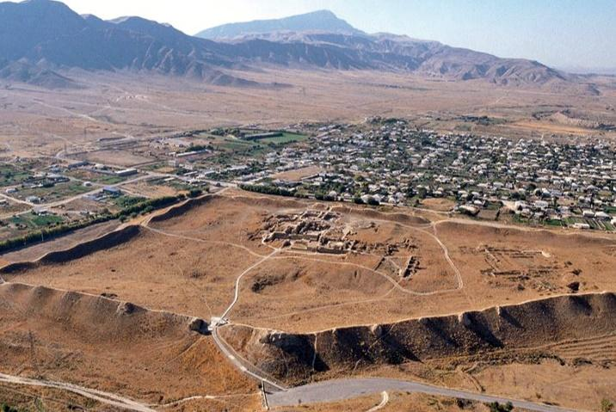
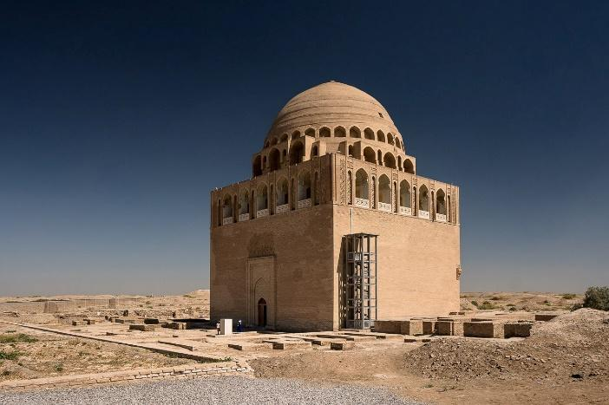
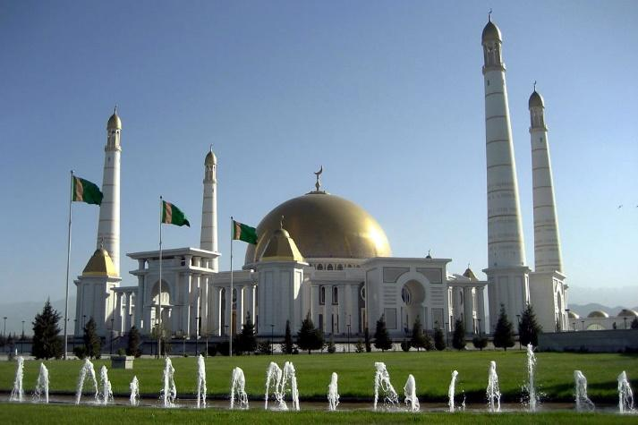

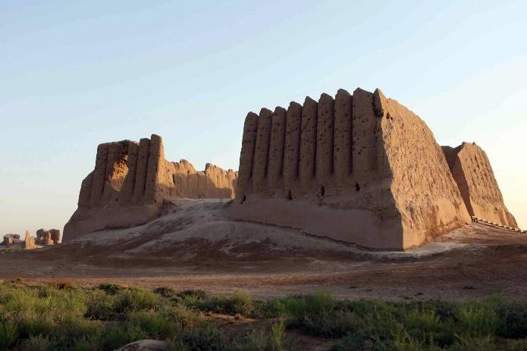

Notes
• This tour is operated on an individual basis.
• The itinerary may be adjusted depending on domestic flight schedules, weather conditions, and road conditions.
• Accommodation in the Darvaza area is simple and is provided in tents or yurt-style desert camp conditions.
• Some driving days are long, but they allow travelers to experience the full geographic diversity of Turkmenistan within one itinerary.

